**Question 1: Find out the mail servers of the following domains: ibm.com, wipro.com**

**Solution:** Open Terminal.

**For ibm.com -**

Type the command **nslookup**

**set type=mx**

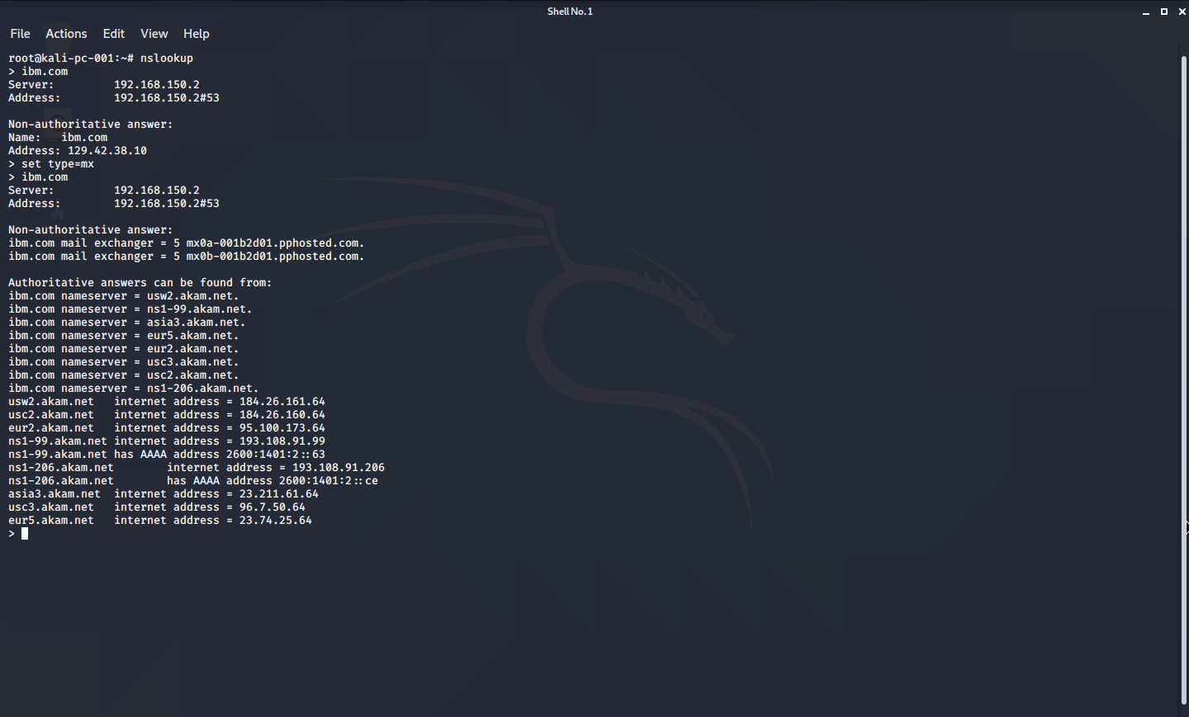**ibm.com**

**For wipro.com -**

Type the command **nslookup**

**set type=mx**

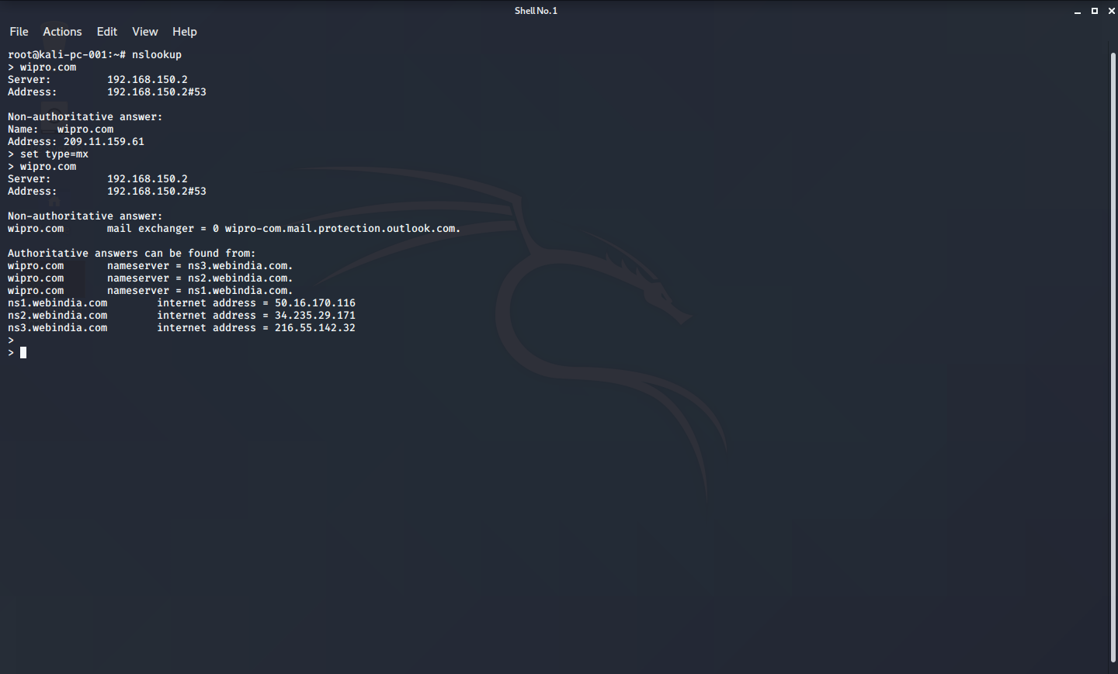**wipro.com**

**Question 2: Find the locations, where these email servers are hosted.**

**Solution:**

**Mail server locations for ibm.com are :-**

1. **mx0a-001b2d01.pphosted.com**

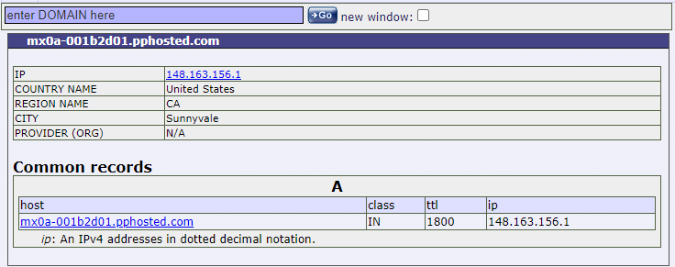

1. **mx0a-001b2d01.pphosted.com**

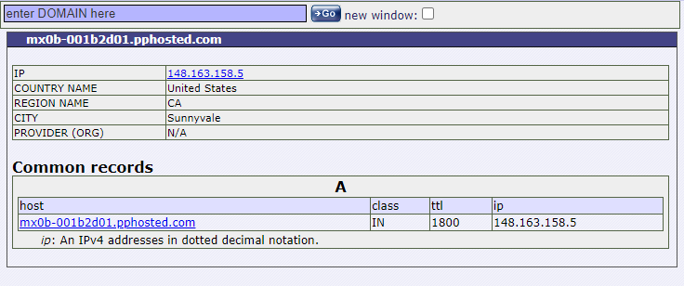

**Mail server location for wipro.com is :-**

**wipro-com.mail.protection.outlook.com**

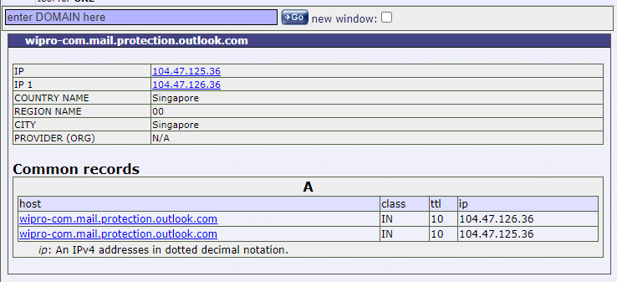

**Question 3: Scan and find out port numbers open 203.163.246.23**

**Solution:** The given IP was scanned using NMAP

Command: nmap 203.163.246.23

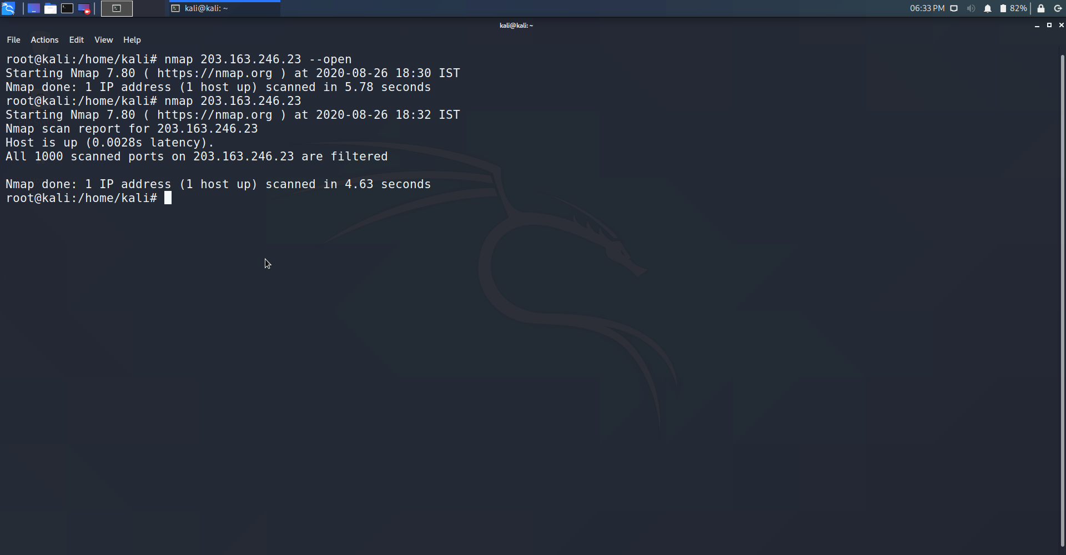

**Question 4: Install Nessus in a VM and scan your laptop/desktop for CVE.**

**Solution:**

1. Navigate to <https://www.tenable.com/downloads/nessus>

2. Download the appropriate version.

3. Register with the website with name and email to get the authentication code via email.

4. Go to Kali terminal, cd to Downloads folder.

5. Dpkg -i < file name>

6. type command /bin/systemctl start nessusd,server

8. Open link https://kali:8834/

7. Enter AUTH code sent via email.

9. Wait for initialization to complete.

10. Log on to Nessus.

11.Goto Advanced tab and create a scan against the local system.

12. Click on the Scan to get the list of vulnerabilities

